**Object detection by template matching :**

**(1) Read our image as rgb and gray image :**

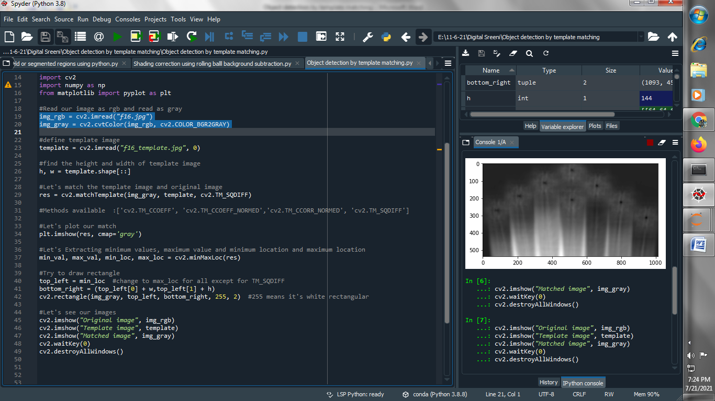

**(2) Read template image :**

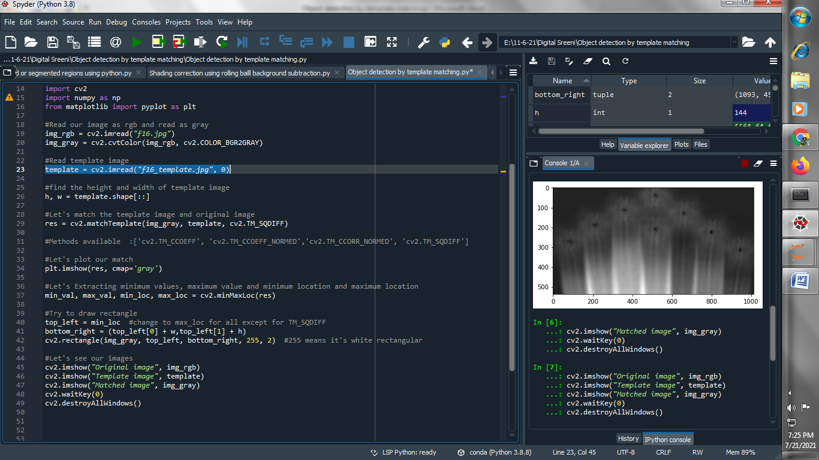

**(3) find the height and width of template image :**

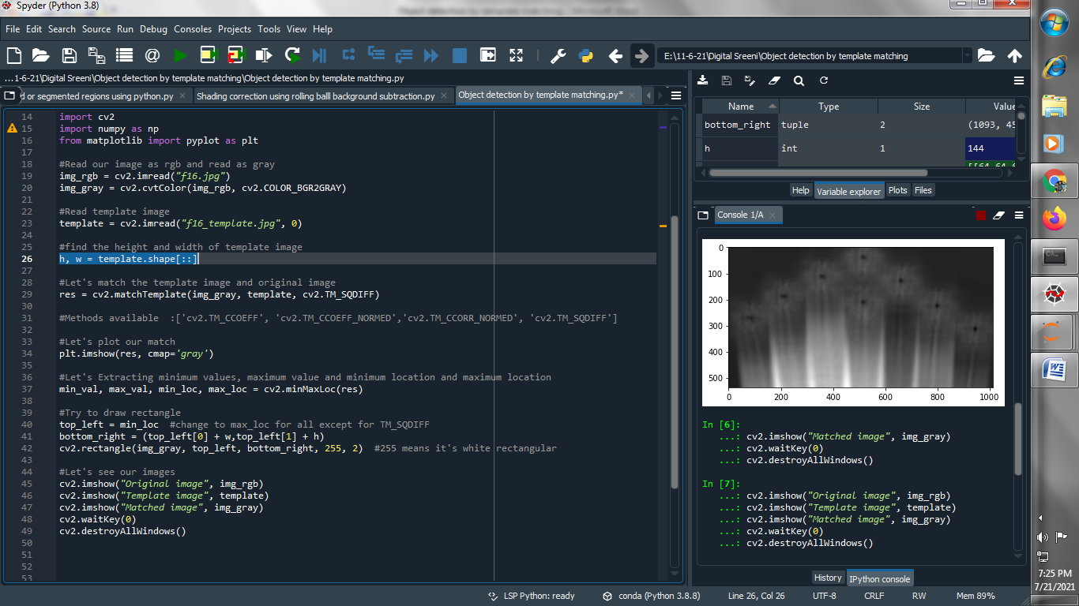

**(4) Let's match the template image and original image :**

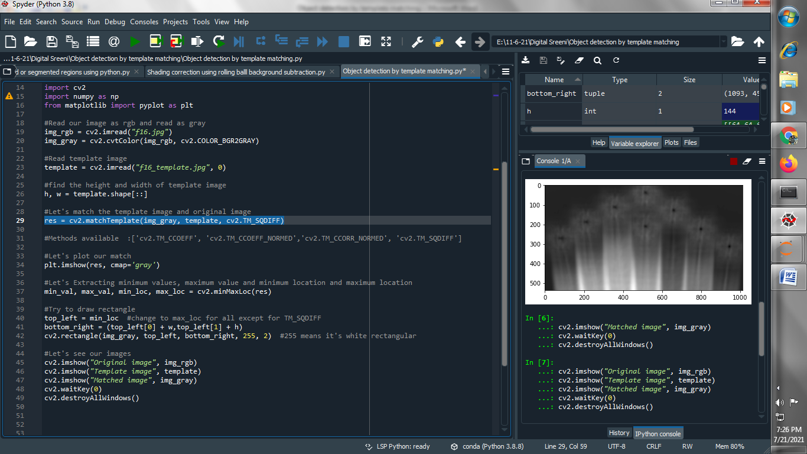

**(5) Let's plot our match :**

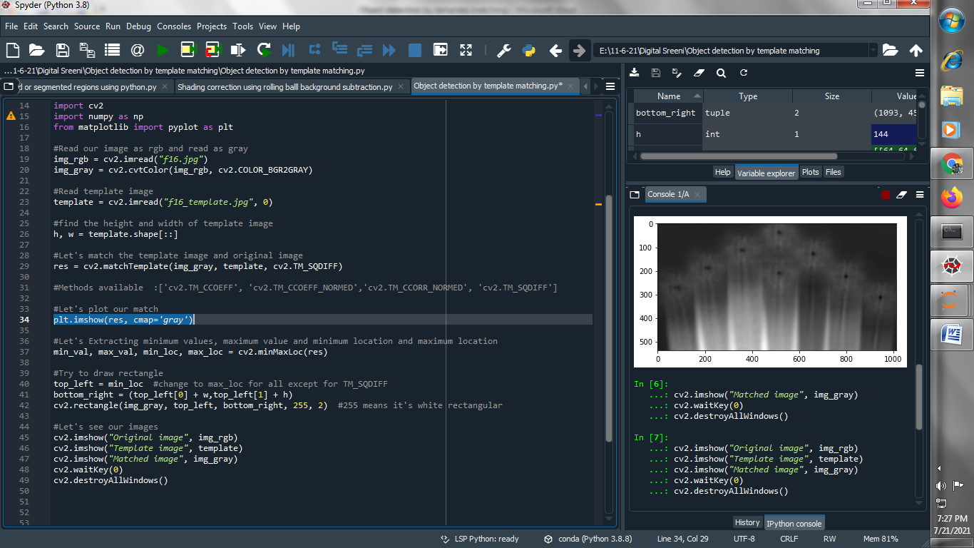

**(6) Let's Extracting minimum values, maximum value and minimum location and maximum location :**

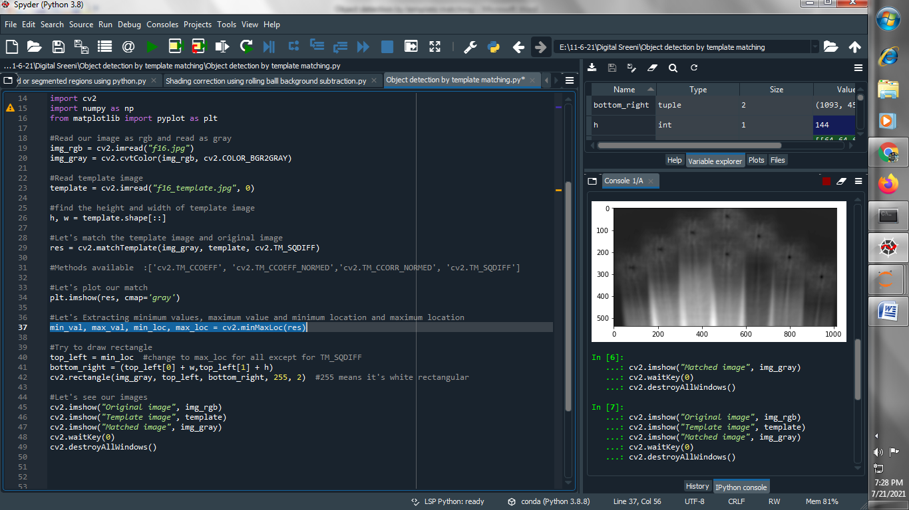

**(7) Try to draw rectangle :**

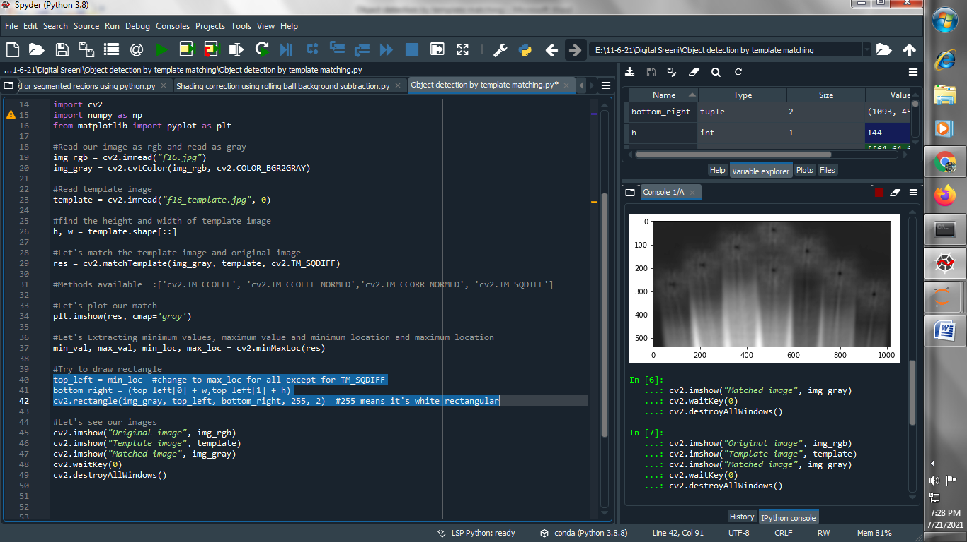

**(8) Let's see our images :**

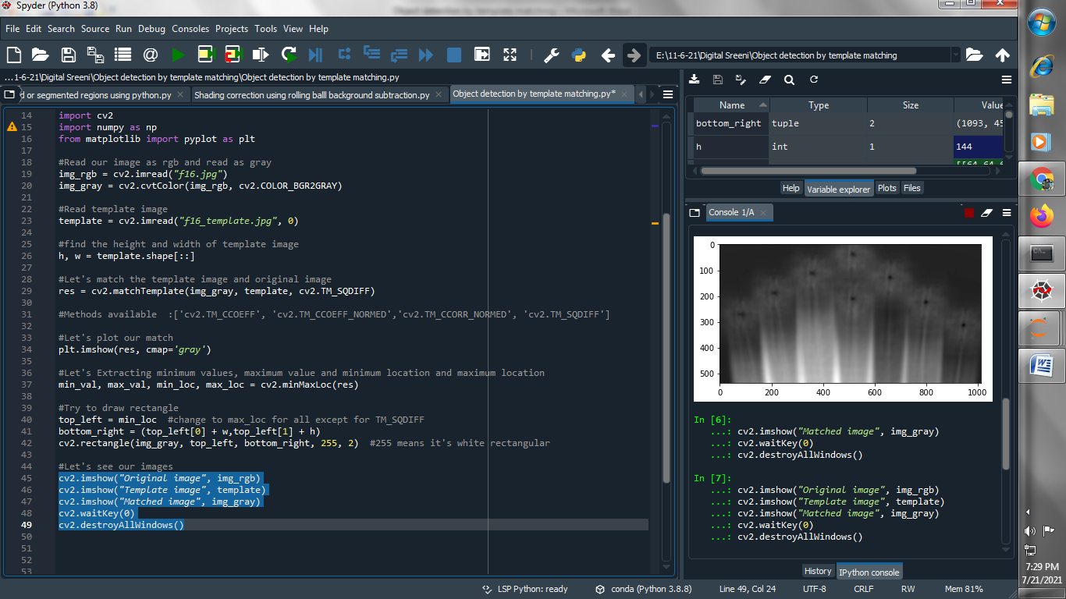

**Output :**

**Original image :**

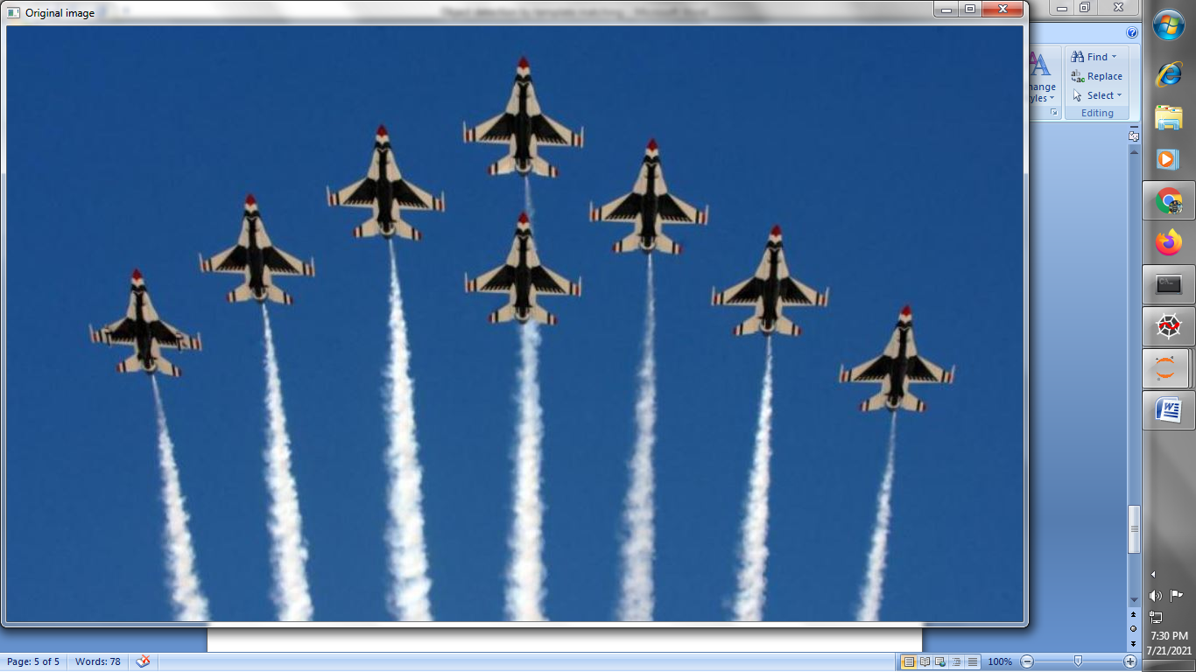

**Template image:**

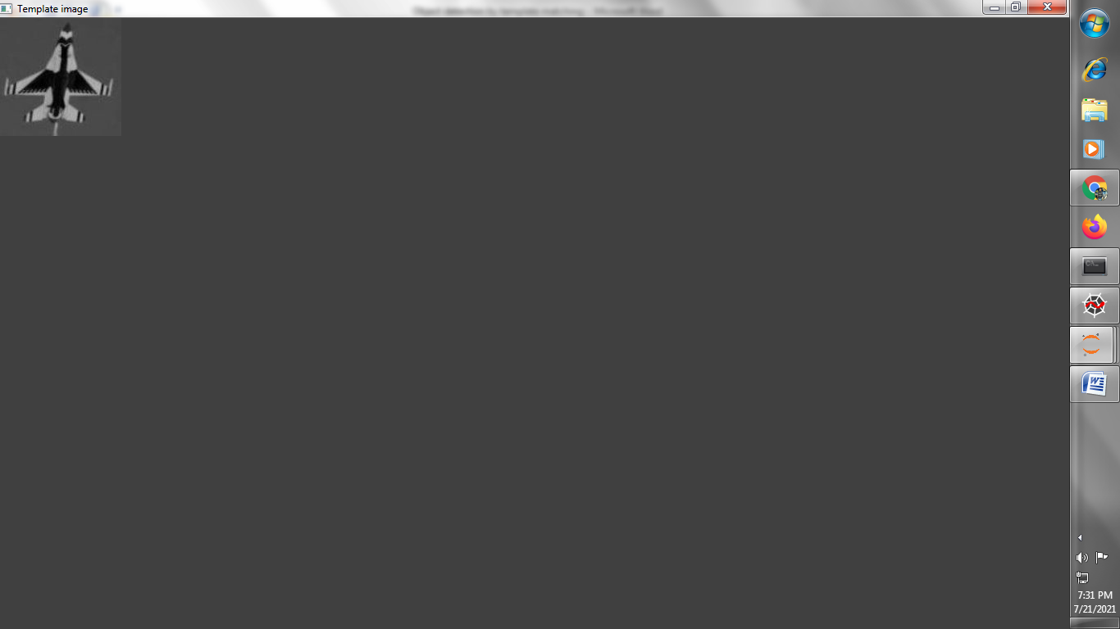

**Matched the image :**

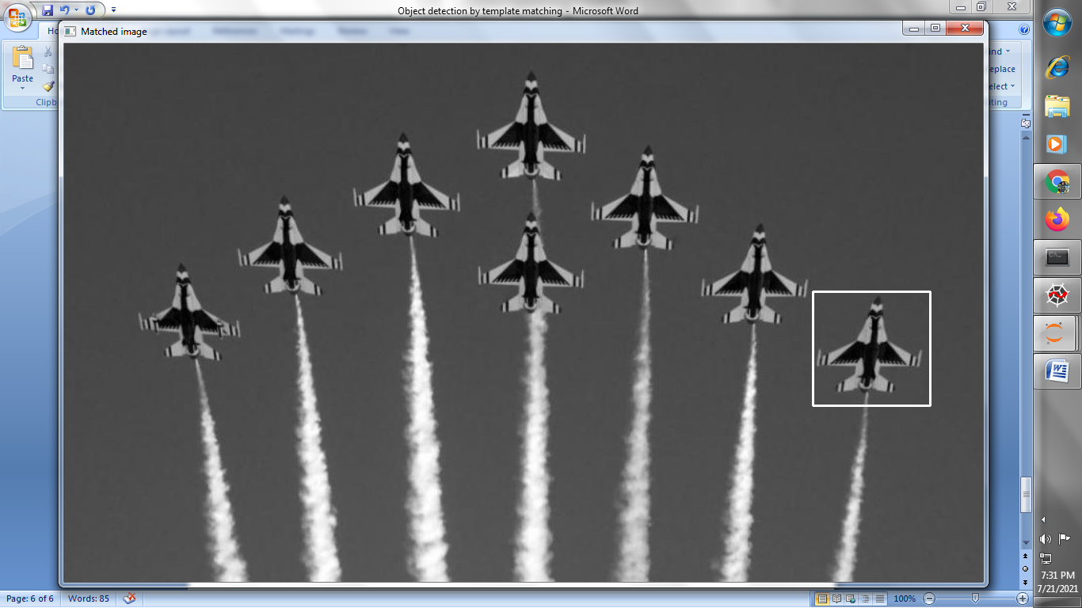

**→ Let's take another example to detect multiple objects :**

**(1) Read our RGB image and Gray level image :**

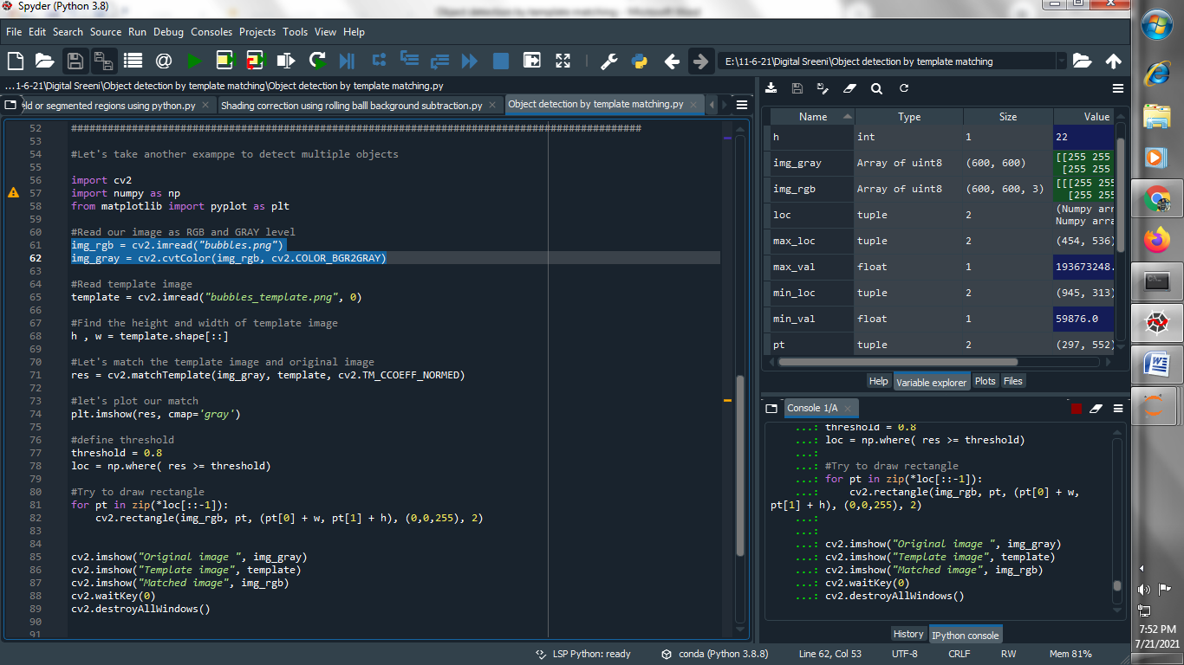

**(2) Read template image :**

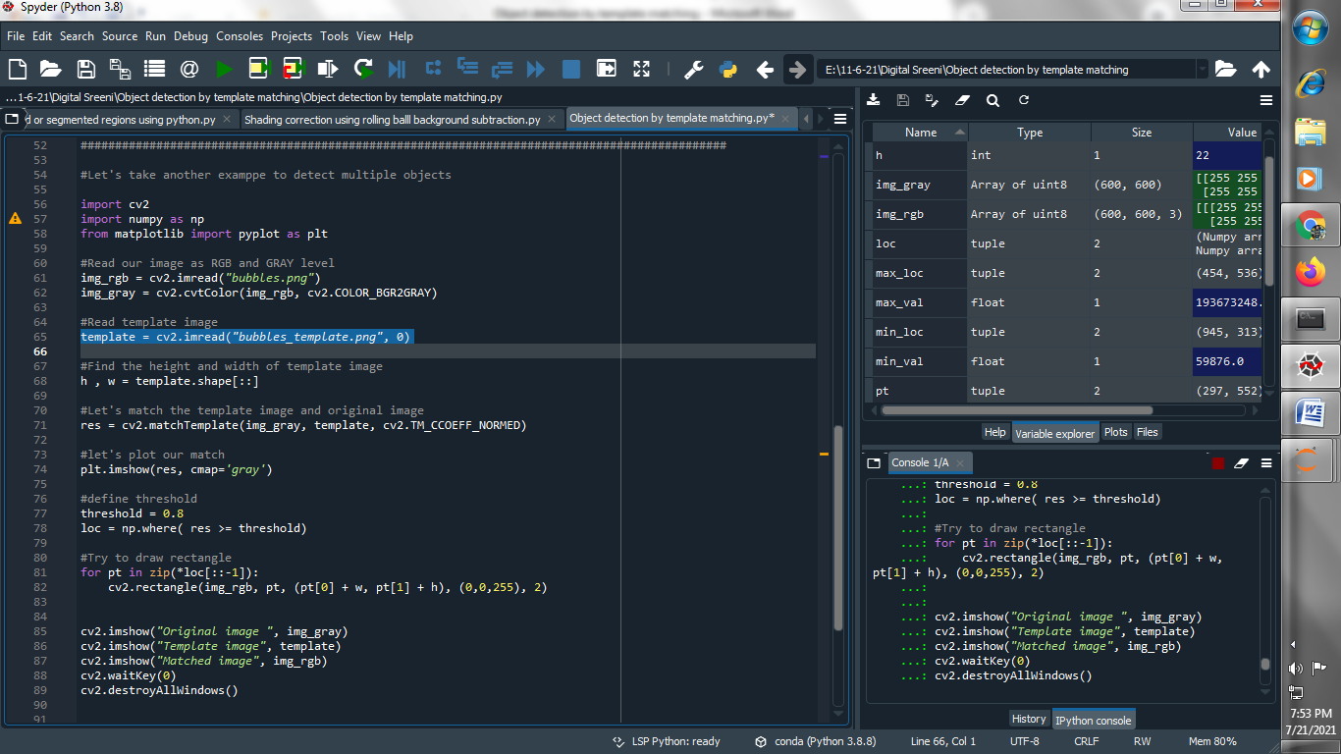

**(3) Find the height and width of template image :**

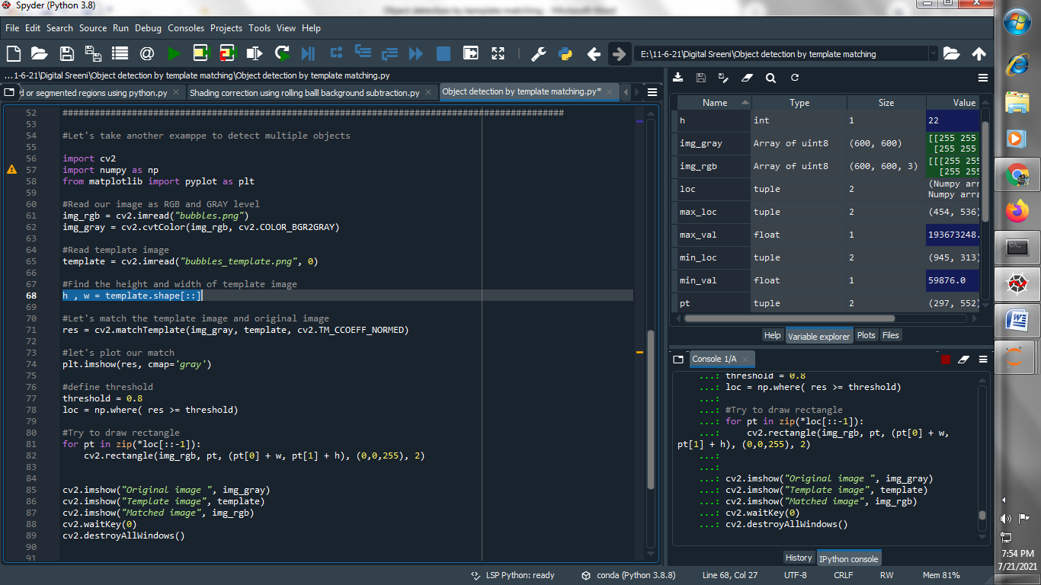

**(4) Let's match the template image and original image :**

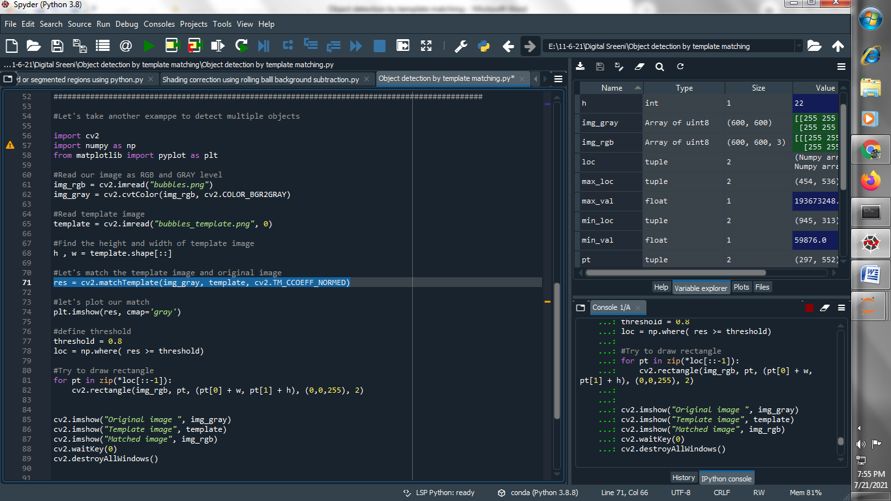

**(5) let's plot our match :**

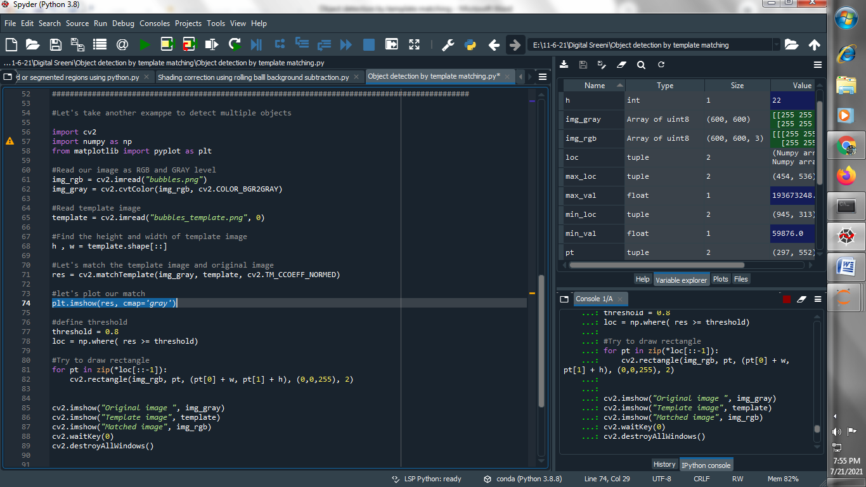

**Output :**

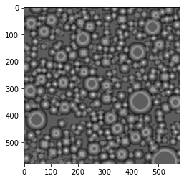

**(6) define threshold :**

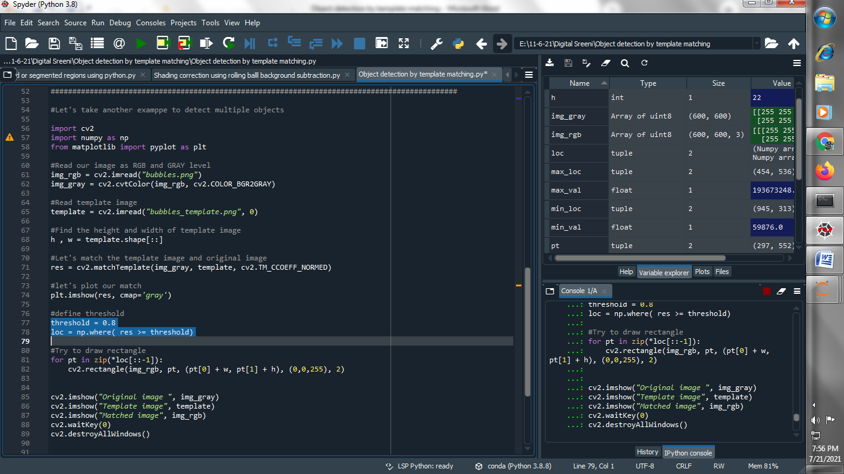

**(7) Try to draw rectangle :**

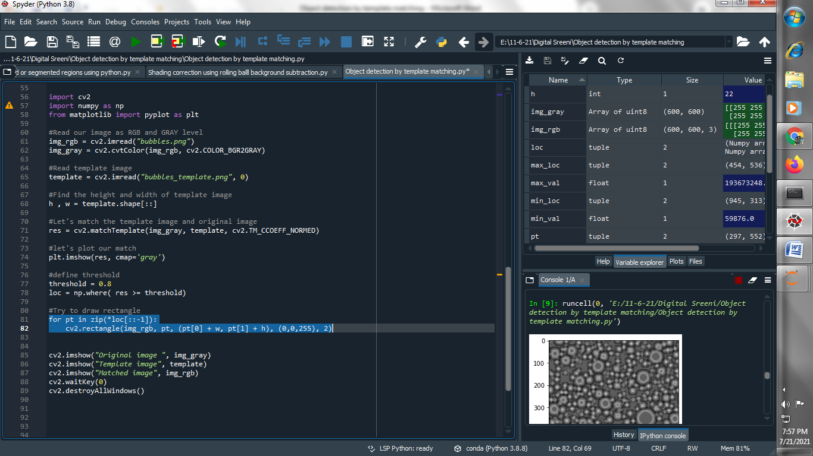

**(8) Let’s see our images :**

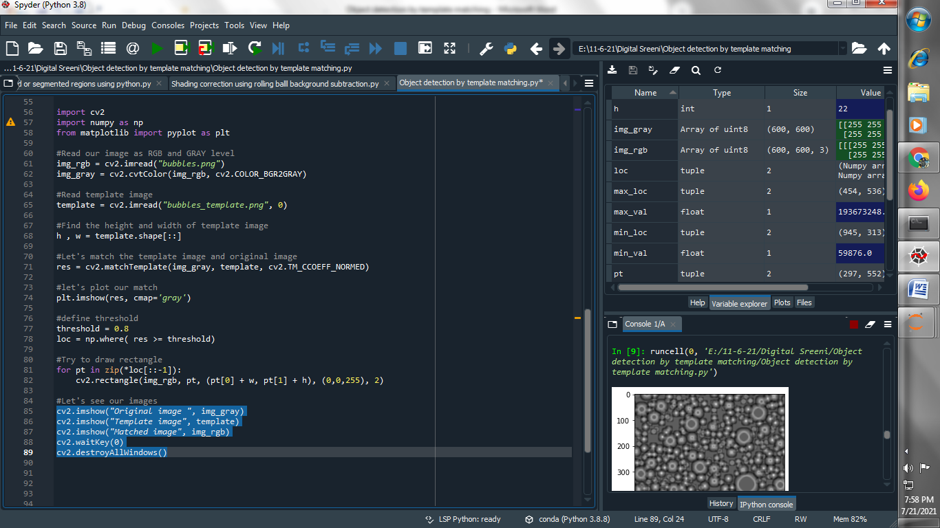

**Output :**

**Original image :**

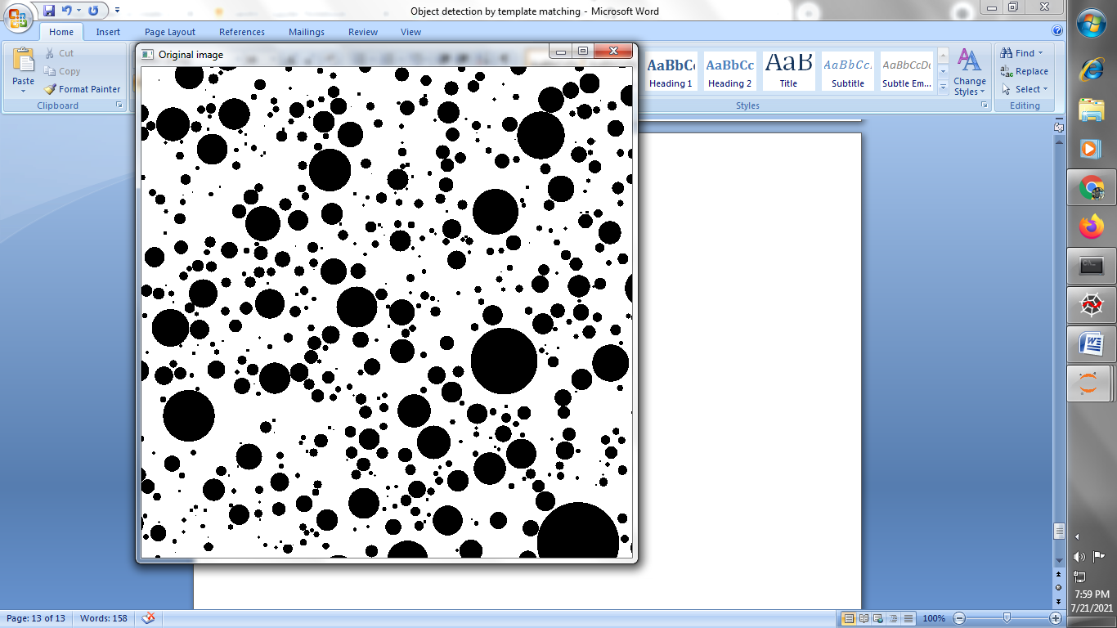

**Template image :**

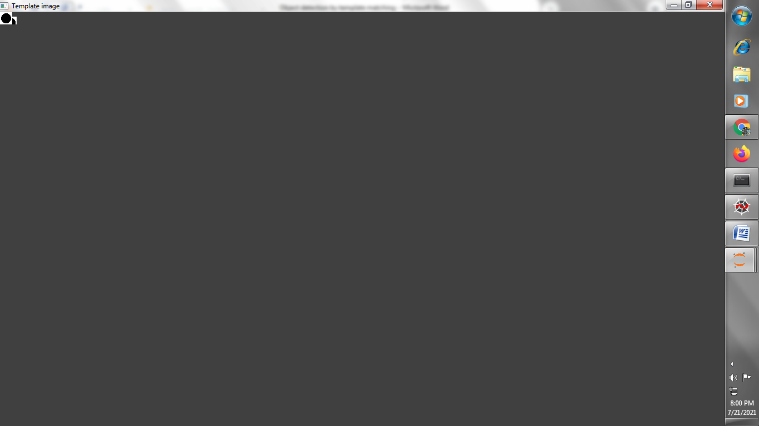

**Matched image :**

